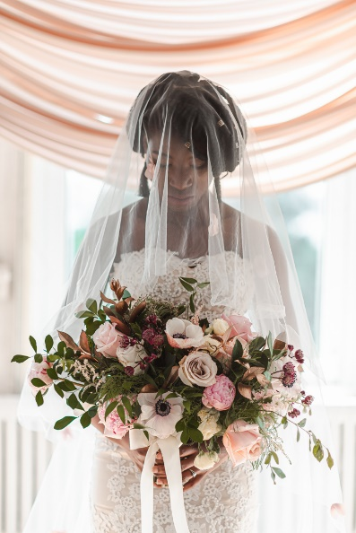
In these uncertain times, many think that waiting to see what will happen next is the best course of action, especially when it comes to planning large events like a wedding. Here at Wedding M.D., we understand the impulse, and you of course must do what you feel is best for you and your family. We also must follow the instructions that have been given by the government and do our part to “flatten the curve.” However, there may be some unintended consequences to just waiting it out. Here’s our best advice for those who are already planning as well as those who are ready to start planning their weddings.
What to do if you have a wedding planning in March, April, or May: If you haven’t already done so, I highly suggest contact all your vendors immediately to discuss a change of plans. As a wedding planner, we have had these discussions with all our clients and are there to help reschedule and come up with alternate plans as necessary. Each vendor has their own contracts and rules that they will have to follow, but we help clients review contracts, initiate conversations with other vendors, and adjust plans to ensure that our clients get what that they need.
It’s a difficult situation for everyone, and you may not be able to reschedule your wedding. However, remember the reasons you initially planned for your big day and what you were hoping to get out of it. If possible, rescheduling as opposed to cancelling will give you the opportunity to fulfill those dreams, albeit not when you had originally planned.
What to do if you already have a wedding planned in June or later: The best advice is to wait and see, although discussing back up plans is a good idea. Reach out to any vendors that you already have booked and ask them for their best advice right now, and potentially other dates to see what’s available. Keep in mind that with weddings from the prior three months moving out, dates may be limited for all your vendors, so please be flexible about the date you’d like to move to should it become necessary. There’s hope that it won’t come to this, and all of us are hoping that life will return to normal sooner rather than later. Especially if you already have some vendors booked for a fall wedding, it’s best to get your other vendors booked ASAP to ensure you can get the vendors that you need. If you need help doing so, please reach out so we can assist you directly.
What to do if you haven’t yet started planning your wedding: Perhaps you recently got engaged and you haven’t yet started to plan. Or maybe you started to plan but have put things on pause due to the extenuating circumstances we’re all experiencing due to COVID-19. To be honest, right now is an excellent time to proceed with plans! There are a few things to keep in mind: 1) with weddings moving out, dates will be limited for the foreseeable future. If you book now, you have a better chance of getting what you want then people who wait until after the pandemic has passed. 2) Yes, it’s true we have no idea what’s going to happen. But we do know that we will get through this current crisis. Be sure your contracts have contingencies planned for what happens if it you do have to reschedule later and be sure to get wedding insurance! While wedding insurance won’t cover the pandemic, there are other reasons to get insurance. 3) If your economic circumstances have changed because of COVID-19, you should wait before planning your wedding. Hopefully we will all get through this unscathed, but it’s more important to protect yourself and your finances as best as you are able. Weddings can be expensive, and you don’t want to run in to issues later on if you no longer have the finances to do so.
Navigating this new world is a challenge for everyone, for couples and vendors alike. While I can’t predict the future, I do know that we will get through this. I’m here to help plan and make your life easier. If you need help, or you just want to discuss your current mindset towards wedding planning, please schedule a consultation so we can help you get moving. And when the world is ready to move forward, you’ll be one step ahead of the game.

